Date : 23rd April , 2026
Name : Isha Rijal

Solution — End-to-End Flow
The pipeline moves raw multi-source data through ingestion to cleaning to transformation and analytics output, all orchestrated on AWS with PySpark as the compute engine.
Step 1 : Data Ingestion: Raw data (scraped + third-party) lands in AWS S3 under s3://hospitaldatacapstone/ .
Each dataset (patients, subscribers, claims, groups, hospitals, etc.) is stored as a separate folder/file.
Step 2 : Data Cleaning (PySpark on Databricks): Each dataset goes through a cleaning module null detection, null imputation (replace with "NA"), deduplication, and type casting.
Cleaned outputs are written back to S3 at s3://hospitaldatacapstone/cleaned-data/.
Step 3 : Load to Redshift (Staging): Cleaned data is loaded into Redshift staging tables under schema project_staging using COPY commands from S3.
Step 4 : Transformation & Use Case Resolution (PySpark): Business logic is applied via PySpark jobs or Redshift SQL to join, aggregate, and filter data for each use case.
Step 5 : Output to Redshift (Results): Each use case result is written to a dedicated table in Redshift schema project_output.

Step 6 : Visualization: Databricks notebooks render charts and dashboards from result tables for stakeholder presentations.
Step 7 : CI/CD: Code is pushed to GitHub via PyCharm and deployed to Databricks via pipeline.

Use Cases
All 13 business questions map to individual output tables in project_output:
Use Case
Use Cases | Key Tables Used
Diseases with max number of claims | Claims, diseases
Subscribers aged < 30 with any subgroup | Subscriber, group , subgroup
Group with maximum subgroups | subgroup_group
Hospital serving most patients | Hospital , patients
Subgroup subscribed most times | subscriber, group_subgroup
Total rejected claims count | claims
City from where most claims originate | claims,patient
Groups of policies subscriber subscribe mostly Government or private | Subscriber, group
Avg monthly premium paid | Subscriber
Most profitable group | Claim, group , subscriber
Patient below 18 admitted for cancer | patients, claims, disease
Cashless insurance patients with charges ≥ 50,000 | patients, claims, subscriber
Female patients > 40 with knee surgery in past year | patients, claims

3. Database Design
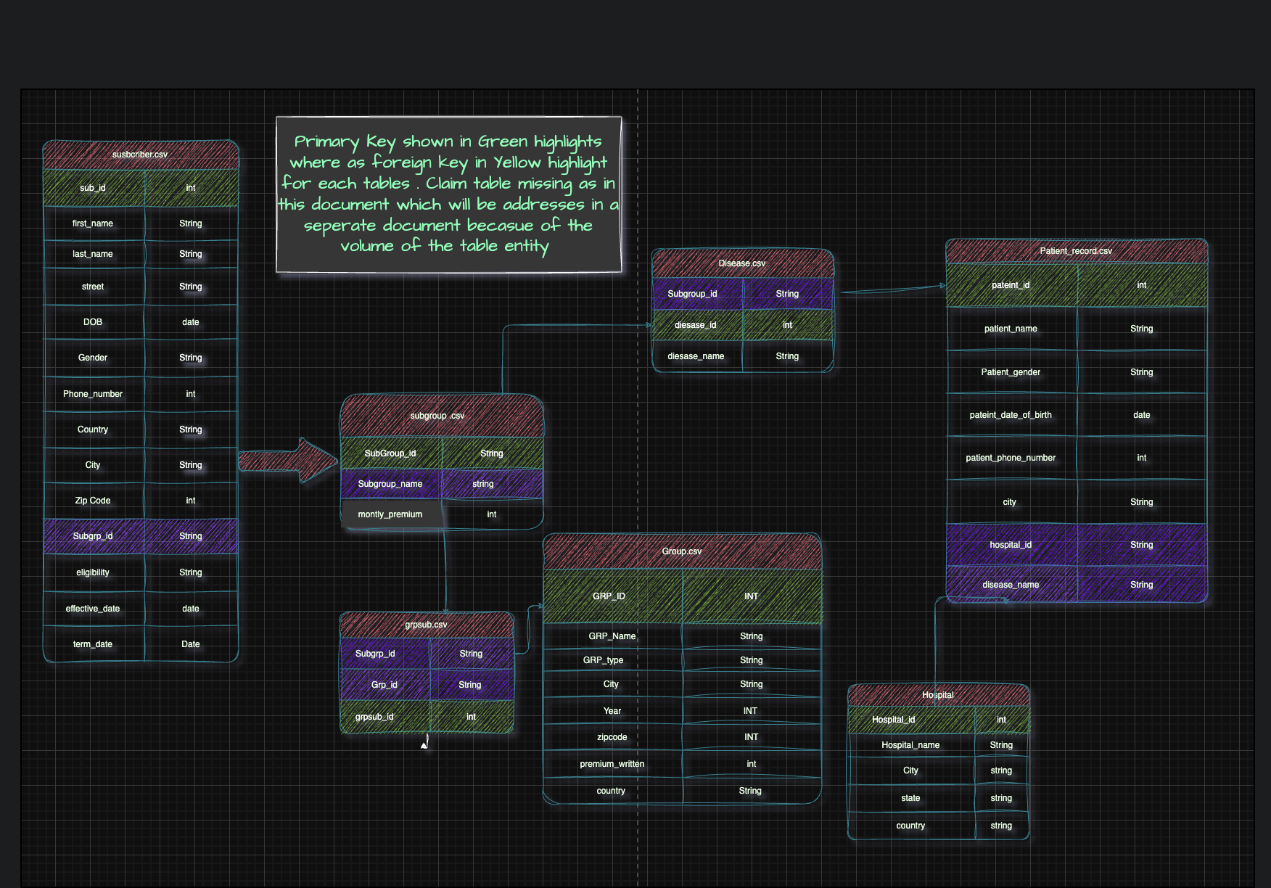

Figure 1: Entity-Relationship (ER) diagram illustrating the primary key (PK) and foreign key (FK) relationships across the core dimension tables of the Healthcare Insurance data model. The Claims table has been omitted from this diagram due to the high number of associated entities and foreign key references; it is documented separately in the schema design.

3.1 Tables Metadata — PK/FK Relationships

Here's the full Redshift schema with all staging tables, keys, and relationships:

3.2 Table Metadata Detail
Table | PK | FK(s) | Description
patients | patient_id | — | Master patient demographics
subscriber | subscriber_id | patient_id, group_id, subgroup_id | Subscription + premium info
group | group_id | — | Government vs. private group types
group_subgroup | subgroup_id | group_id | Subgroups under each group
claims | claim_id | patient_id, subscriber_id, disease_id, hospital_id, | Central fact table for all claims
disease | disease_id | — | Disease/diagnosis lookup
hospital | hospital_id | — | Hospital location master
diseases | disease_id | — | Surgical/medical procedure lookup

Output Tables (schema: project_output): One table per use case e.g. out_uc01_disease_max_claims, out_uc02_subscribers_under30, out_uc11_cancer_under18, etc.

Technology and Platform to be used in this solution :
- AWS Glue
- AWS S3
- AWS redshift
- Pyspark
- Databricks

